**AMERICAN INTERNATIONAL UNIVERSITY–BANGLADESH (AIUB)**

**FACULTY OF SCIENCE & TECHNOLOGY**

**DIGITAL LOGIC AND CIRCUITS LAB**

**Summer 2022-2023**

Section: F

Group Number: 02

**EXPERIMENT NO. 5**

**NAME OF THE EXPERIMENT**

*Construction of Diode and Transistor Logic Gates*

**Supervised By**

SHAHRIYAR MASUD RIZVI

Faculty of Engineering, AIUB

**Submitted By**:

|  |  |
| --- | --- |
| **Name of the Student** | **ID Number** |
| 1. NOKIBUL ARFIN SIAM | 21-44793-1 |
| 1. AHNAF AHMED | 20-42173-1 |
| 1. SAIFUL ISLAM | 20-42585-1 |
| 1. MAHADI HASAN | 19-39711-1 |
| 1. SHEIKH FAHIM FUAD | 21-44721-1 |

**Part I: Construction of Diode Logic Gates**

**Introduction:**

A diode is a two-terminal electrical device that allows current to flow in one direction but not the other. It is like a pipe with an internal valve that allows water to flow freely in one direction but shuts down if the water tries to flow in another direction. The diode’s two terminals are called the anode and cathode. In the diode symbol, the arrow points from the anode (the flat part of the triangle) toward the cathode (the point of the triangle).

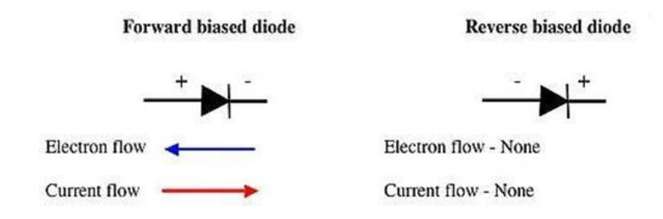

The device operates by allowing current to flow from the anode to the cathode, basically in the direction of the triangle. Recall that current is defined to flow from the more positive voltage toward the more negative voltage (electrons flow in the opposite direction). If the diode's anode is at a higher voltage than the cathode, the diode is said to be forward biased, its resistance is very low, and current flows. If the anode is at a lower voltage than the cathode, the diode is reverse-biased, its resistance is very high, and no current flows. The diode is not a perfect conductor, so there is a small voltage drop, approximately 0.7 V, across it.

In this group of experiments, we will implement some logic functions using the DL circuits and discover the potential benefits and problems of using the DL logic.

**Theory and Methodology:**

***Diode Logic OR Gate:***

A Diode Logic (DL) OR gate consists of nothing more than diodes (one for each input signal) and a resistor. Here, the 10 kΩ resistor (*R*) is added to provide a ground reference for the output signal. If there are no input signals connected to the diodes, the output will be ground, or logic 0. Thus, an open input is equivalent to a logic 0 input and will have no effect on the operation of the rest of the circuit. It is possible to add any number of input diodes to this circuit, each with its separate input signal. However, two inputs are quite sufficient to demonstrate the operation of the circuit.

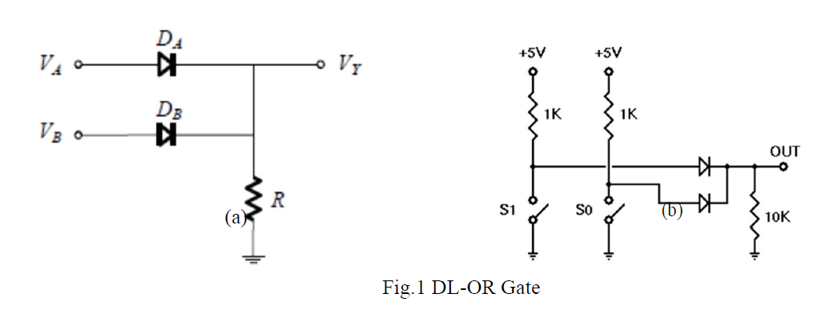

Assuming the diodes are ideal, the voltage truth table as given in Table 1(a) is obtained. The corresponding logic truth table is given in Table 1(b):

***Diode Logic AND Gate:***

A Diode Logic AND gate consists of diodes (one for each input signal) and a resistor. As with the DL OR gate, the 10KΩ resistor (R) provides a reference connection. Unlike the OR gate, however, this is a reference to +5 volts, rather than to ground. If there are no input signals connected to the diodes, the output will be +5 volts, or logic 1. Thus, an open input will not affect the rest of the circuit, which will continue to operate normally.

As with DL-OR gates, it is possible to add any number of input diodes to this circuit, each with its separate input signal. However, two inputs are quite sufficient to demonstrate the operation of the circuit.

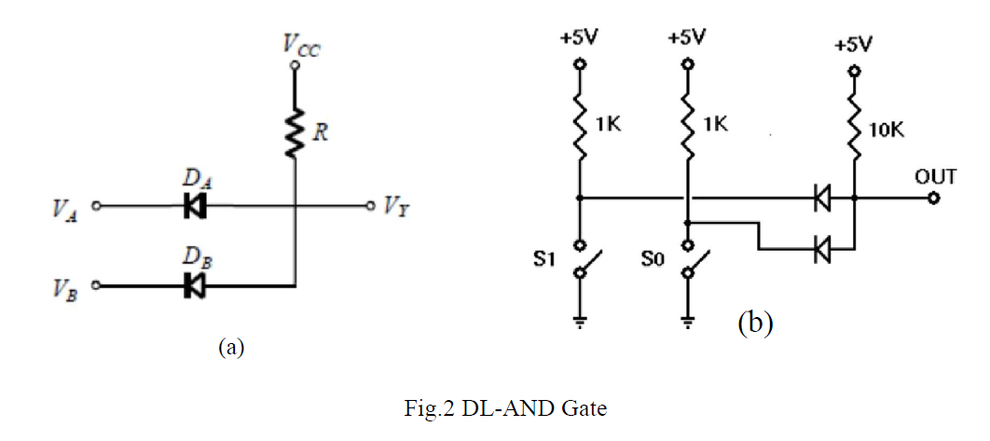

Assuming the diodes are ideal, the voltage truth table of the above AND gate is as given in Table 2(a). The corresponding logic truth table is in Table 2(b).

**Apparatus:**

(1) 10 kΩ ohm resistor (Color band: brown-black-orange).

(2) 1N914/1N4002 diodes or equivalent.

(3) Connecting wires.

(4) Trainer Board

**Introduction:**

A bipolar transistor is a three-terminal semiconductor device. Under the control of one of the terminals, called the base, current can flow selectively from the collector terminal to the emitter terminal.

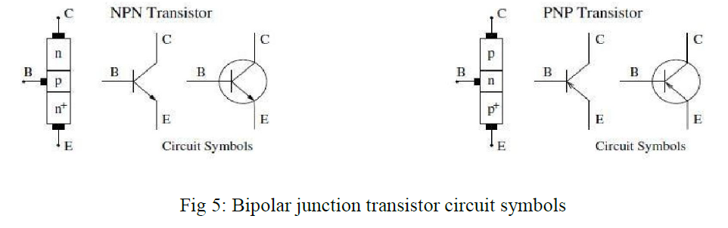

In this experiment we examine how to build logic gates from bipolar transistors using the RTL, DTL and TTL design.

**Theory and Methodology:**

***Resistor-Transistor Logic (RTL):***

Resistor-Transistor Logic (RTL) is a large step beyond Diode Logic (DL). Basically, RTL replaces the diode switch with a transistor switch. If a +5v signal (logic 1) is applied to the base of the transistor (through an appropriate resistor to limit base-emitter forward voltage and current), the transistor turns fully on and grounds the output signal. If the input is grounded (logic 0), the transistor is off and the output signal is allowed to rise to +5 volts. In this way, the transistor not only inverts the logic sense of the signal, but it also ensures that the output voltage will always be a valid logic level under all circumstances. Because of this, RTL circuits can be cascaded indefinitely, where DL circuits cannot be cascaded reliably at all.

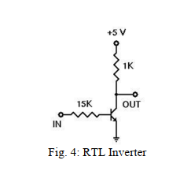

***Diode-Transistor Logic:***

Diode–Transistor Logic (DTL) is a class of digital circuits built from bipolar junction transistors (BJT), diodes and resistors; it is the direct ancestor of transistor–transistor logic (TTL). DTL offers better noise margins and greater fan-outs than RTL, but suffers from low speed (especially in comparison to TTL). RTL allows the construction of NOR gates easily, but NAND gates are relatively more difficult to get from RTL. DTL, however, allows the construction of simple NAND gates from a single transistor, with the help of several diodes and resistors.

***Transistor-Transistor Logic:***

We can think of a bipolar transistor as two diodes placed very close together, with the point between the diodes being the transistor base. Thus, we can use transistors in place of diodes to obtain logic gates that can be implemented with transistors and resistors only; this is called transistor-transistor logic (TTL).

One problem that DTL doesn't solve is its low speed, especially when the transistor is being turned off. Turning off a saturated transistor in a DTL gate requires it to first pass through the active region before going into cut-off. Cut-off, however, will not be reached until the stored charge in its base has been removed. The dissipation of the base charge takes time if there is no available path from the base to ground. This is why some DTL circuits have a base resistor that's tied to ground, but even this requires some trade-offs. Another problem with turning off the DTL output transistor is the fact that the effective capacitance of the output needs to charge up through Rc before the output voltage rises to the final logic '1' level, which also consumes a relatively large amount of time. TTL, however, solves the speed problem of DTL elegantly.

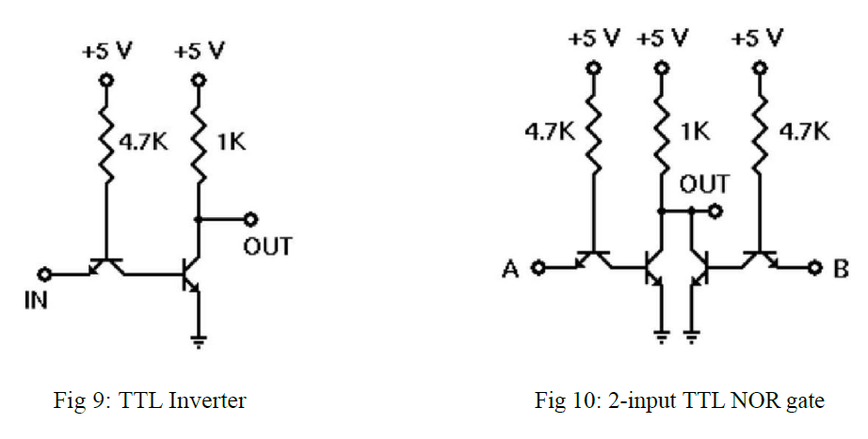

***Emitter-Coupled Logic (ECL):***

The operation of Emitter-Coupled Logic (ECL) is that whenever the HIGH input is given to any one of the ECL circuits, it will make the transistors ON. So, this will pull the output, *Vo,* down to LOW.

Similarly, when the LOW input value is given to all the transistors’ input then it will make all the transistors OFF. So, it will make the output, *Vo* be pulled up to the HIGH value because of the drop within 640 Ω resistance.

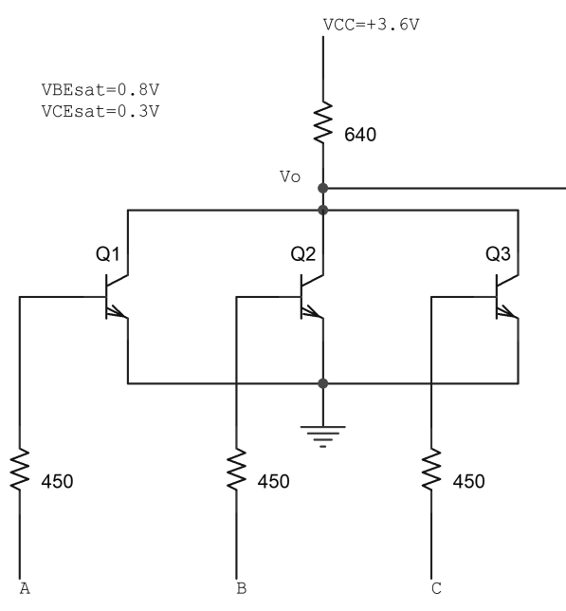

Fig. 8 A 3-input ECL NOR gate

**BJT Pin Configuration:**

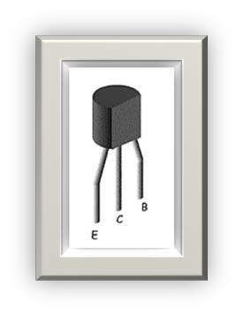

**Apparatus:**

1. 2N4124 NPN silicon transistor (or equivalent).

2. Resistors (15 kΩ, 1 kΩ, 4.7 kΩ)

3. Connecting wires.

4. Trainer Board

**Hardware Implementation:**

**TTL NOR Gate:**



Fig: input 0 0

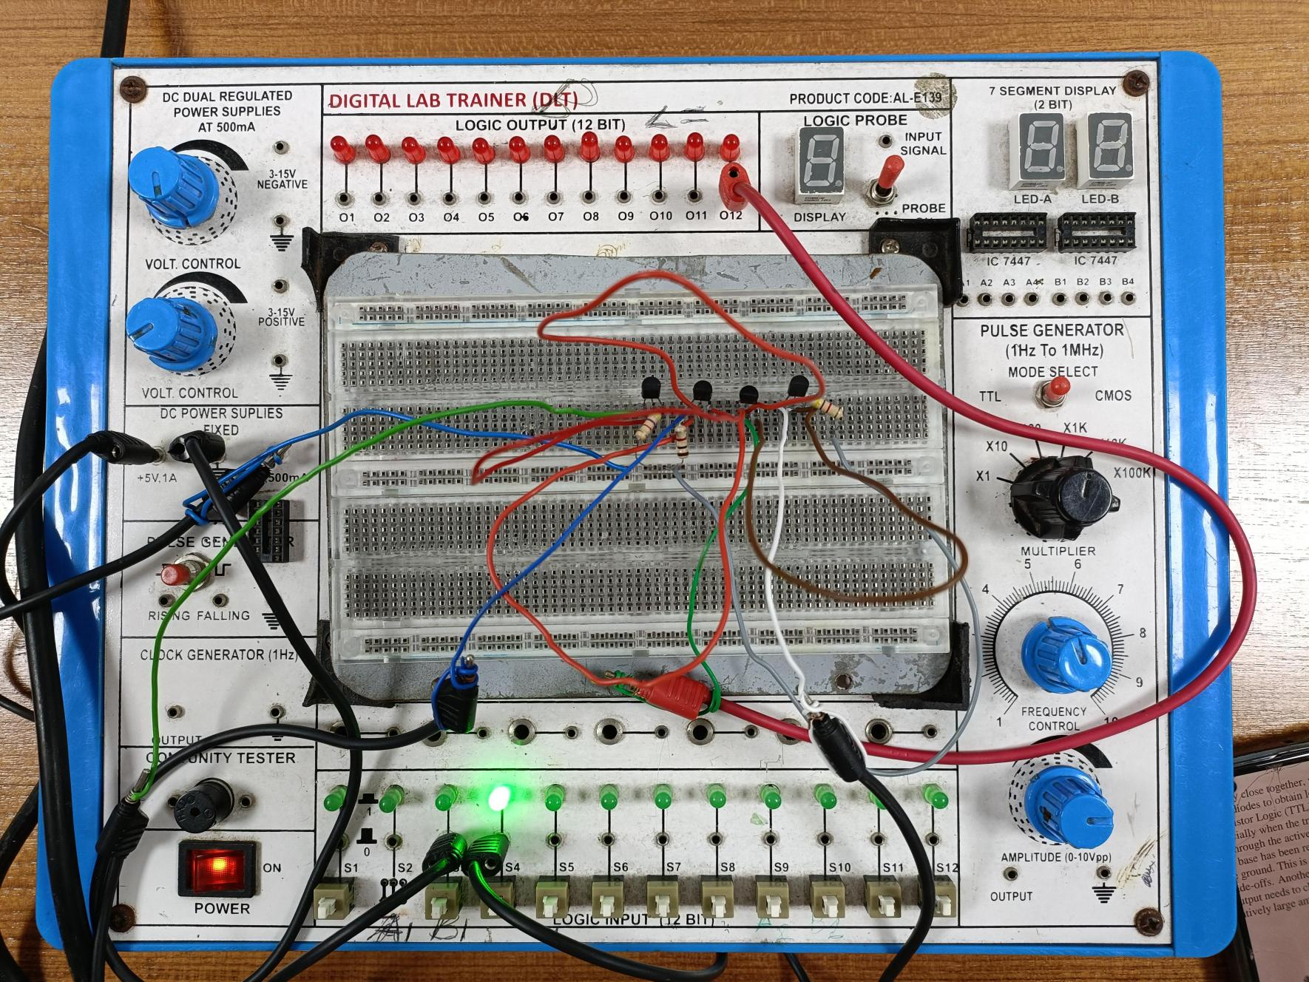

Fig: input 0 1

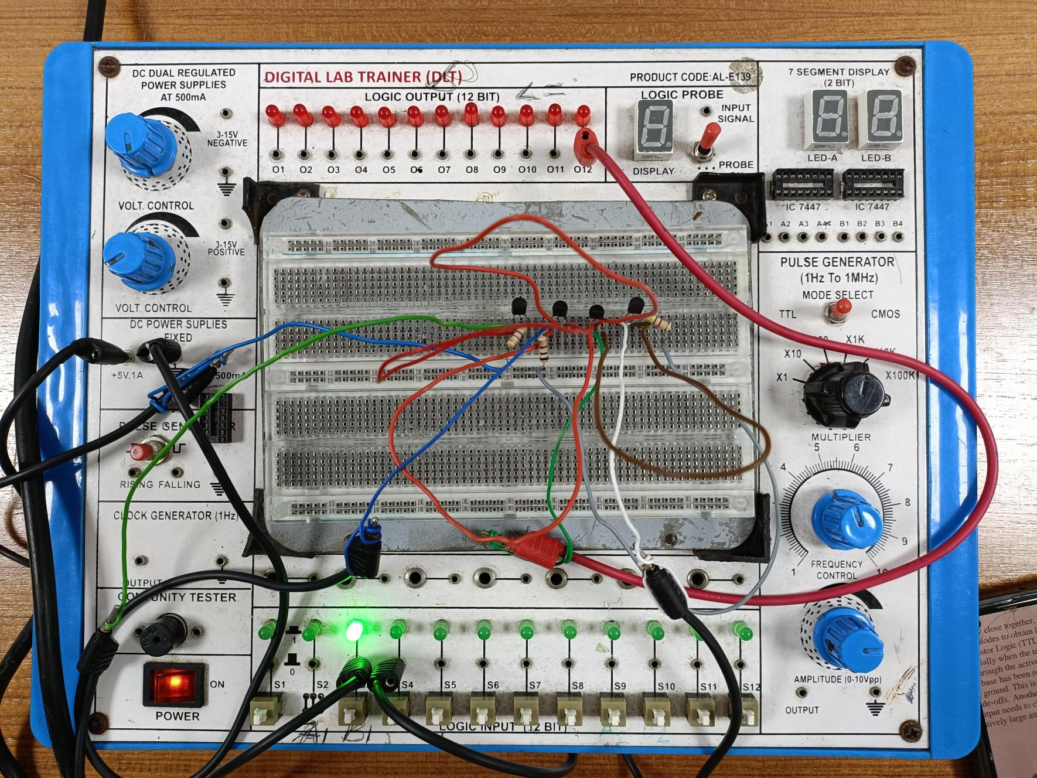

Fig: input 1 0

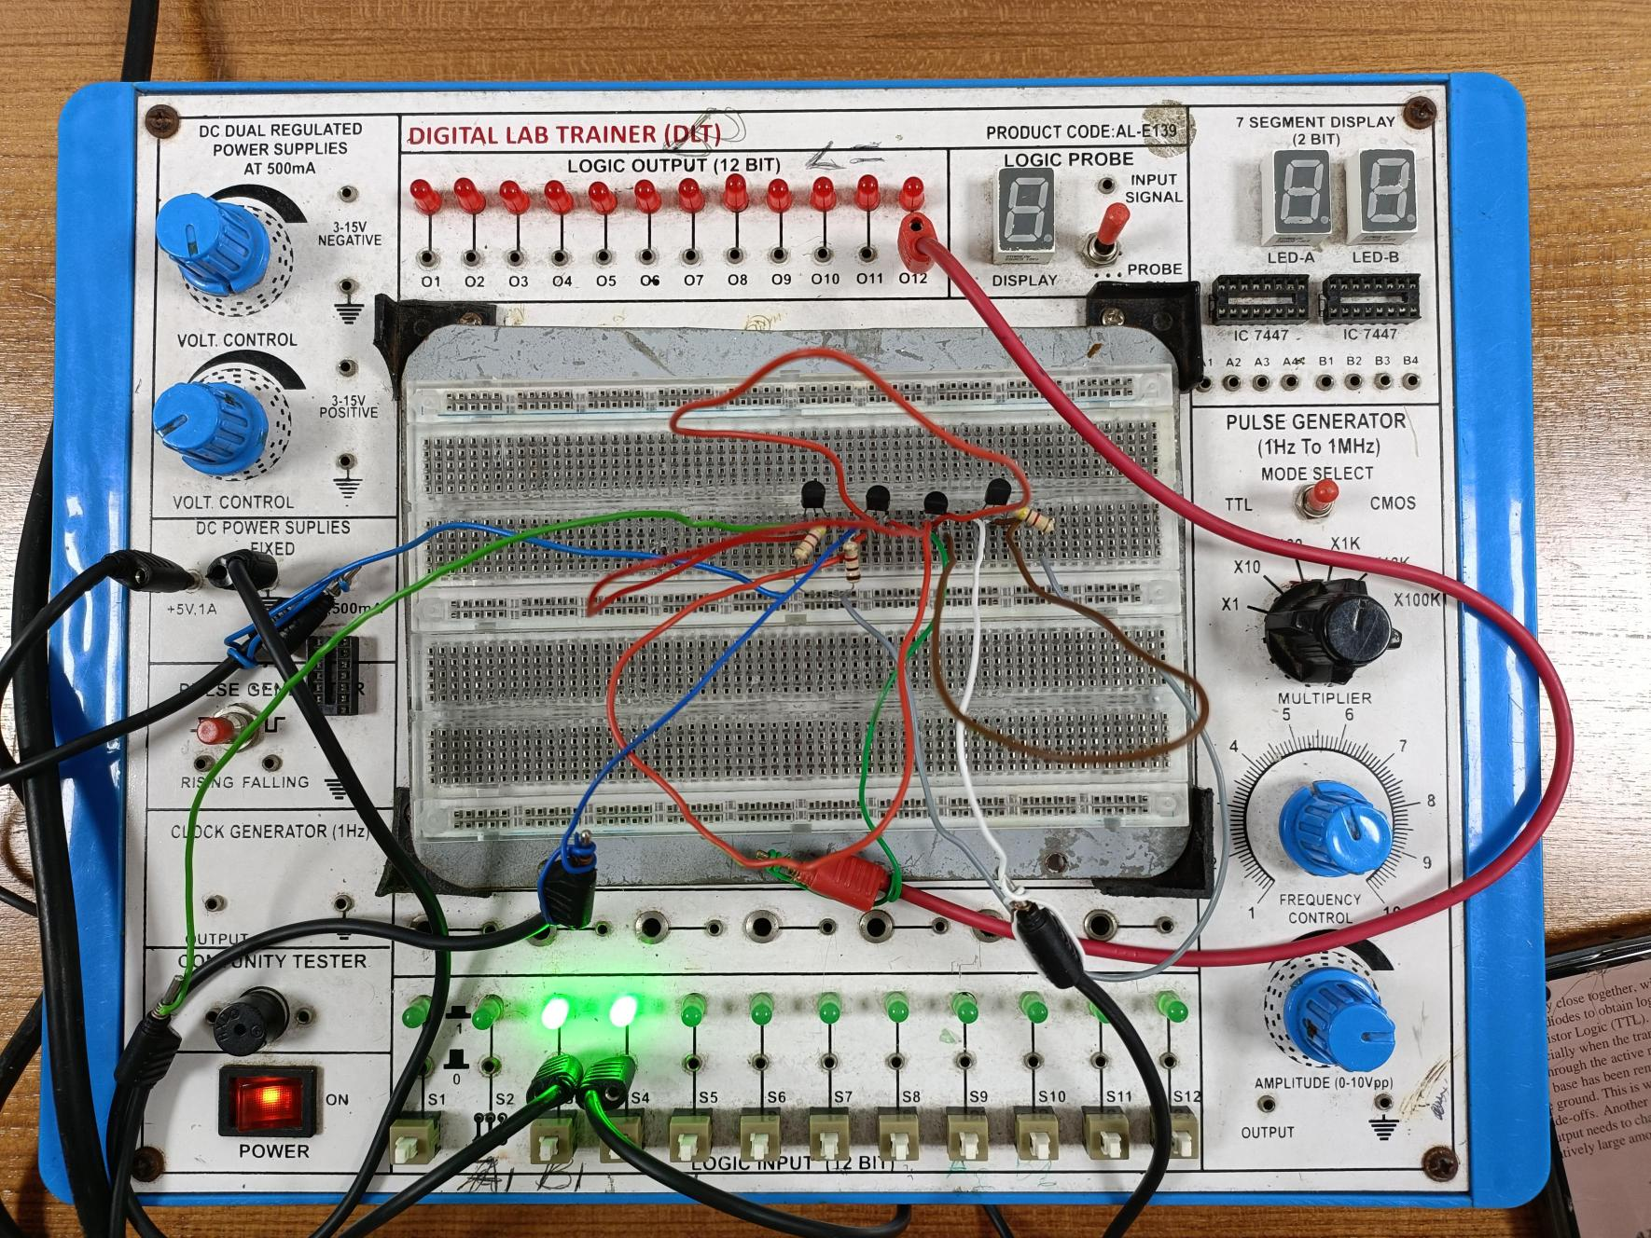

Fig: input 1 1

**Simulation:**

**Part I**

**DL-OR Gate:**

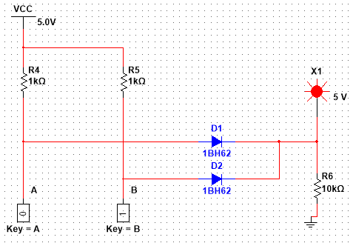

Fig: input- 0 1

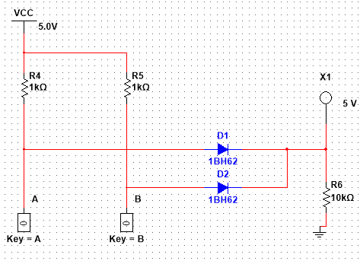

Fig: input- 0 0

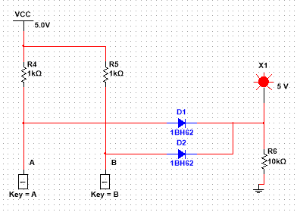

Fig: input- 1 1

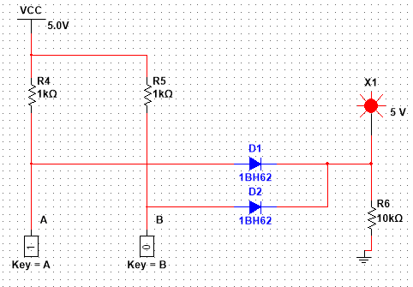

Fig: input- 1 0

**DL-AND Gate:**

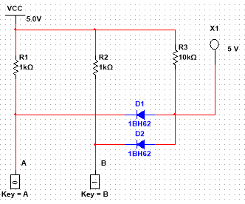

Fig: input- 0 1

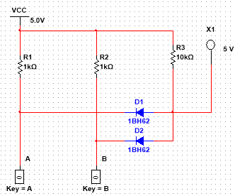

Fig: input- 0 0

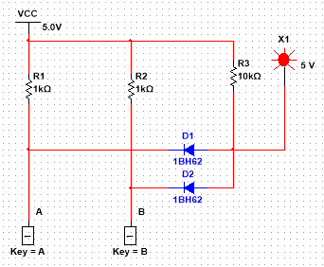

Fig: input- 1 1

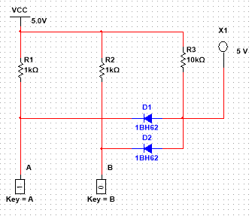

Fig: input- 1 0

**Cccc**

**Part II**

**RTL Inverter:**

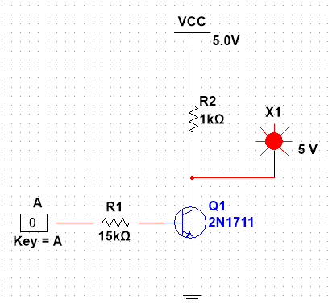

Fig: input- 0

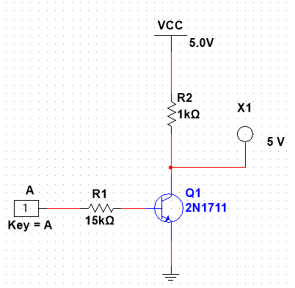

Fig: input- 1

**2-input DTL NAND Gate:**

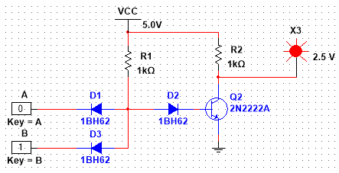

Fig: input- 0 1

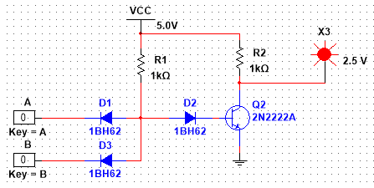

Fig: input- 0 0

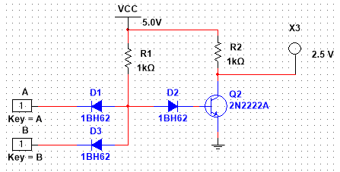

Fig: input- 1 1

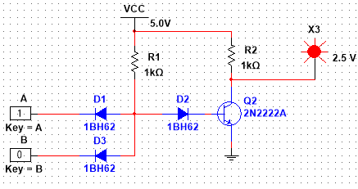

Fig: input- 1 0

Cc

**TTL Inverter:**

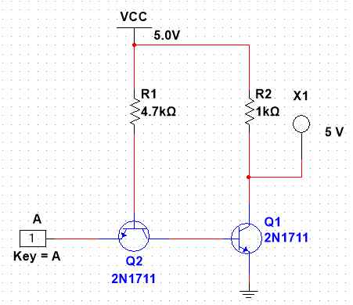

Fig: input- 1

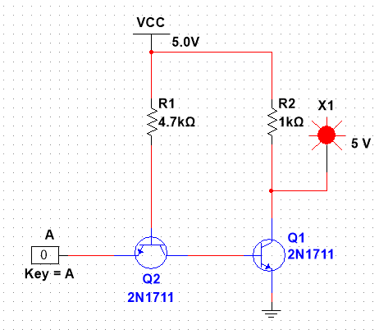

Fig: input- 0

**2-input TTL NOR Gate:**

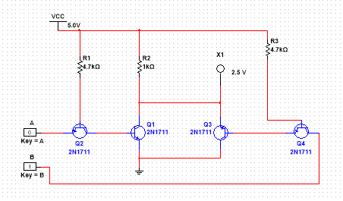

Fig: input- 0 1

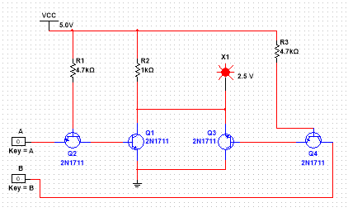

Fig: input- 0 0

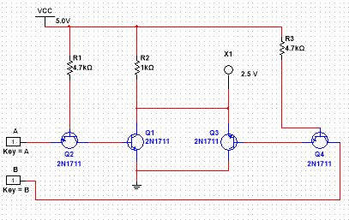

Fig: input- 0 0

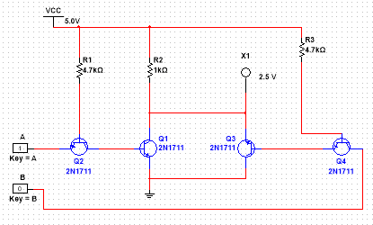

Fig: input- 0 0

**3 input ECL NOR Gate:**

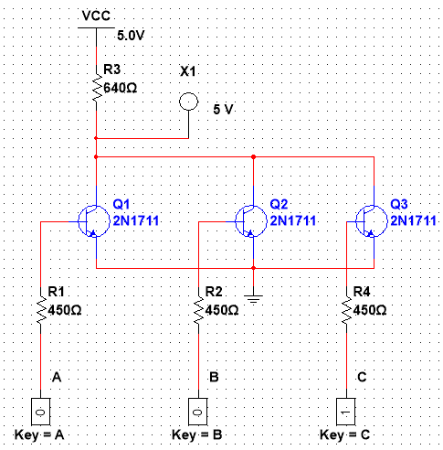

Fig: input- 0 0 1

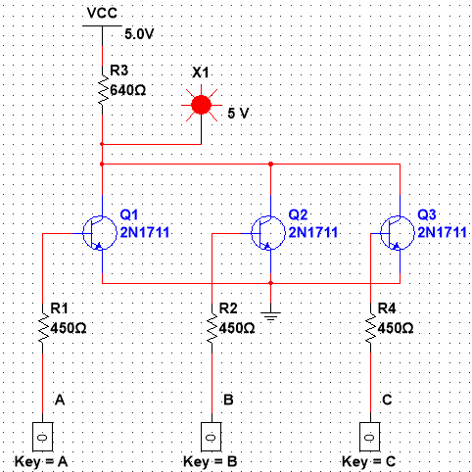

Fig: input- 0 0 0

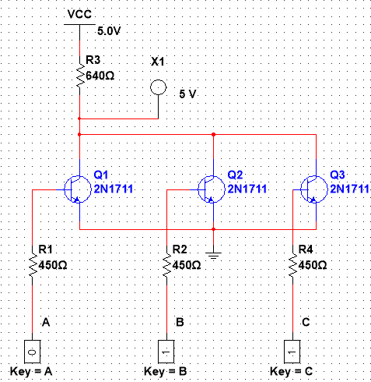

Fig: input- 0 1 1

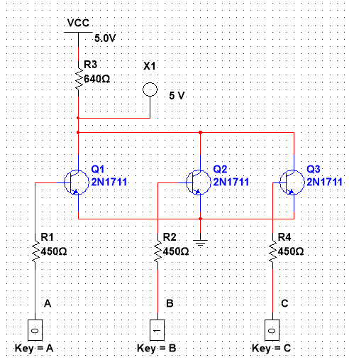

Fig: input- 0 1 0

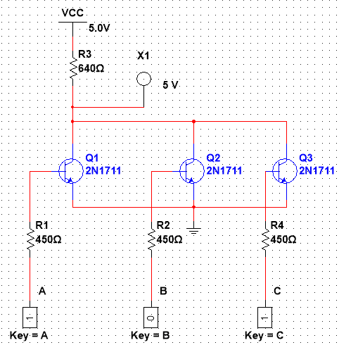

Fig: input- 1 0 1

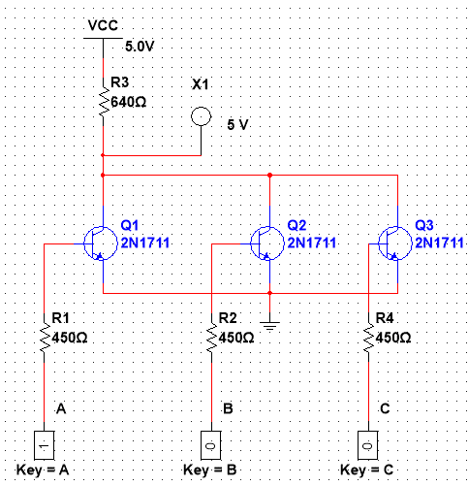

Fig: input- 1 0 0

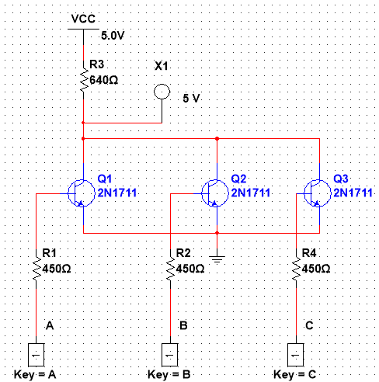

Fig: input- 1 1 1

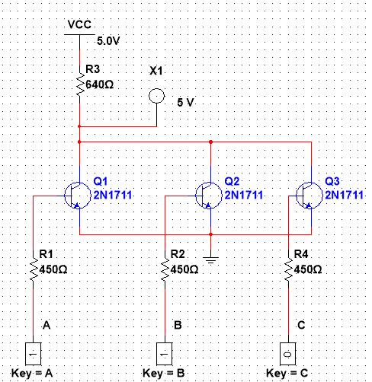

Fig: input- 1 1 0

**Report Question (Part-I)**

1. **What is wired logic?**

**Ans:** Wired logic is a form of digital logic that relies on direct connections between the outputs of logic gates, without the need for additional active components. This technique utilizes the electrical properties of the gates involved. When a logic gate is constructed using passive components like diodes and resistors to implement Boolean algebra, it is referred to as a wired logic connection. Wired logic can be used to create basic logic gates such as AND or OR gates. However, it lacks level restoration capability, and it is not possible to construct a NOT gate using wired logic.

1. **Why are diode logic gates not suitable for cascading operations?**

**Ans:** Diode logic gates are unsuitable for cascading due to their voltage drop and lack of amplification. Diodes introduce voltage drop, limiting voltage available for subsequent stages, causing unreliable logic transitions. Accumulated voltage drop decreases signal voltage, leading to uncertain logic levels. Diodes lack amplification, weakening signals as they pass through gates, making them susceptible to noise. Transistor-based or IC logic gates are preferred, providing amplification and improved voltage levels. Transistors amplify and shape signals, facilitating reliable cascading and offering better noise immunity than diode logic gates.

**Report Question (Part-II)**

**2. Design a 4-input RTL OR gate and explain its operation.**

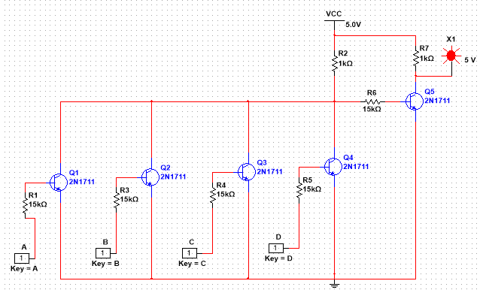

1. **Design a 3-input TTL NAND and NOR gates and explain their operation**

**3 input NAND gate**

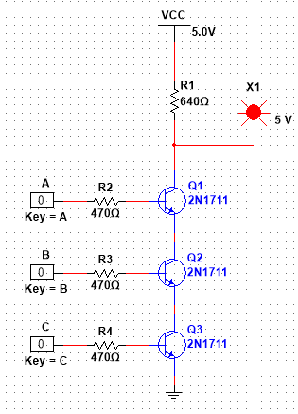

**3 input NOR gate**

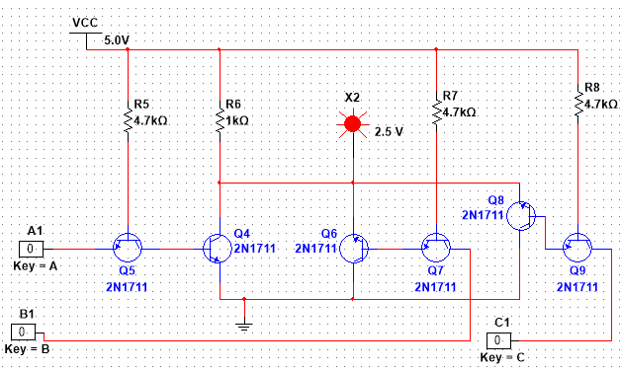

1. **Design a 3-input DTL NAND gate and explain its operation.**

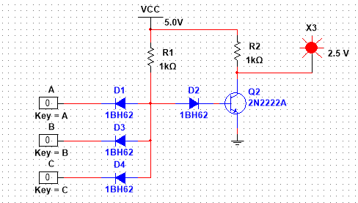

1. **Design a 3-input ECL OR gate and explain its operation.**

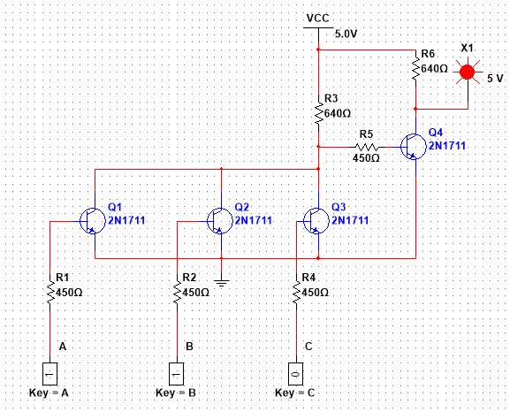

**Results:** The Simulation results matched all our theoretical truth table findings.

**Conclusion:**

The experiment successfully constructed diode and transistor logic gates, including AND, OR, NOT, and NAND gates. Careful connection and configuration of components ensured the desired logic behavior. Precautions were taken to prevent IC damage, such as checking connections, avoiding changes during power-on, and maintaining safe voltage levels. This hands-on experience enhanced understanding of gate operations, logical relationships, and Boolean algebra, providing a foundation for designing complex digital circuits.

**Reference:**

1. Thomas L. Floyd, “Digital Fundamentals,” available Edition, Prentice Hall International Inc.
2. Boylestad, Robert L. Electronic Devices and Circuit Theory. Pearson Education, India, 2009